Title: eBay Kleinanzeigen Used Car Market Intelligence & Pricing Insights

By: Ibraheem Sadu

Date: May 2026

SUMMARY
This project processes and analyzes a raw, highly fragmented dataset from the eBay Kleinanzeigen used car marketplace to extract actionable pricing intelligence. Online vehicle marketplaces are notoriously messy, and this dataset was no exception, containing severe outliers, missing fields, and erroneous records. By implementing a rigorous data cleaning pipeline, over 10,000 invalid or misleading listings were removed, reducing the dataset's price skewness from an unusable 184.91 to a realistic 5.73.
Exploratory data analysis highlighted the core drivers of vehicle depreciation: brand positioning, odometer readings, and vehicle age. Premium brands such as Porsche and Land Rover commanded the highest median prices, while mileage alone accounted for nearly 19% of a vehicle's price variance. Furthermore, value retention analysis utilized log-linear regression to identify the market's "Best Investment Cars," revealing that brands like Daihatsu and Honda suffer the lowest annual depreciation rates (under 7%), making them safe long-term holds for dealers.
To translate these insights into a real-time business application, a deterministic Pricing Intelligence Tool was engineered. Using a 4-level fallback system based on brand, age, and mileage brackets, the tool provides a reliable expected price range (Q1, Median, Q3) for incoming listings. Ultimately, this report equips automotive dealers, resellers, and marketplace platforms with the data-backed benchmarks necessary to optimize inventory margins, avoid overpriced assets, and automate the flagging of fraudulent listings.

INTRODUCTION
The secondary automotive market is highly sensitive to pricing, driven by a complex interplay of brand perception, wear-and-tear, and vehicle age. On peer-to-peer platforms like eBay Kleinanzeigen, pricing is dictated by individual sellers rather than standardized industry valuations. Consequently, the raw marketplace data is riddled with pricing anomalies, placeholder values (e.g., listings priced at 1 or 9,999,999), and inaccurate metadata. This environment creates friction: buyers struggle to identify fair market values, dealers risk acquiring depreciating inventory at premium prices, and platforms lose user trust due to misleading listings.
To navigate this fragmented landscape, robust data-driven pricing strategies are critical. The goal of this analysis is to transform raw, noisy marketplace listings into a structured pricing intelligence system. Specifically, the project addresses several core business objectives outlined in the project brief:
- Establishing reliable, data-backed pricing benchmarks across diverse automotive brands.
- Understanding the quantitative impact of vehicle age and mileage on resale value.
- Identifying automotive brands that best retain their value over time, highlighting them as strong inventory investments.
- Deploying a pricing estimator tool that provides immediate, interpretable pricing guidance for real-world application.
By addressing these objectives, this report provides a strategic framework to help market participants make smarter, more profitable inventory and purchasing decisions.

Dataset Overview
The primary data source is the eBay Kleinanzeigen used car marketplace dataset, scraped in 2016. Initially, the dataset comprised 50,000 individual vehicle listings and 20 attributes capturing both numeric metrics and categorical vehicle specifications.
Key Variables Analyzed:
Variables | Description
Price | The listed selling price of the vehicle (in EUR).
Odometer_km | The vehicle's mileage (in kilometers).
Registration_year | The year the vehicle was officially registered.
Car_age | Engineered feature representing age (2016 - Registration Year).
Brand | The vehicle manufacturer.
Vehicle_type | Categorical classification of the vehicle body style.
Prior to analysis, the dataset exhibited severe quality issues. These included categorical features missing up to 20% of their values, impossible price tags, and registration dates set in the future or in the distant past. Correcting these was mandatory to produce reliable market benchmarks.

Data Cleaning & Preparation
To ensure the integrity of the pricing analysis, a strict preprocessing and outlier removal pipeline was executed. Over 20.5% of the original data (10,241 rows) was removed to eliminate noise.
Column Standardization: German column headers were translated to English and converted from camelCase to standard snake_case formats (e.g., yearOfRegistration to registration_year) to ensure programmatic consistency.
Data Type Conversion: Date-related metadata (e.g., date_crawled, date_created) were parsed into datetime objects. String-based financial and mileage columns containing currency symbols and commas were cleaned and cast into integer data types.
Column Removal Due to Imbalanced/Irrelevant Distribution: Features offering no analytical value for price prediction were dropped entirely. This included scraping metadata, postal_code, highly subjective text like listing name, and columns with near-zero variance like num_pictures and offer_type.
Handling Missing Values: Rather than dropping thousands of rows and losing valuable pricing/brand data, categorical columns with missing data (such as vehicle_type, gearbox, fuel_type, and unrepaired_damage) were imputed with an "unknown" label to preserve the observations.
Handling Outliers: A documented outlier-capping strategy was implemented to simulate standard market conditions:
- Price: Restricted to €500 – €250,000 to eliminate token listings and hyper-exotics.
- Registration Year: Capped between 1950 and 2016 (the scrape year) to prevent negative ages and exclude pre-1950 antiques.
- Mileage & Power: Mileage capped at a realistic 500,000 km, and engine power restricted to between 1 and 1,000 PS.

Exploratory Data Analysis (EDA)
With the dataset reduced to 39,759 high-quality rows, exploratory analysis was conducted to map the financial landscape of the marketplace.

Price Distribution (Before & After Cleaning)
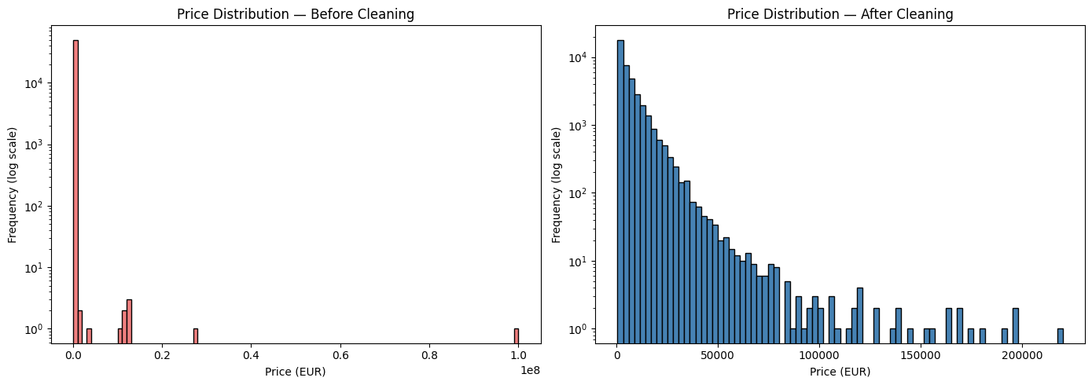
Before cleaning, the price distribution was completely distorted by user errors and placeholders (skewness of 184.91). Following the strict outlier removal, the distribution normalized to a realistic right-skewed shape (skewness of 5.73). The vast majority of standard market inventory transacts below €20,000, validating the cleaning methodology.

Price Vs Brand
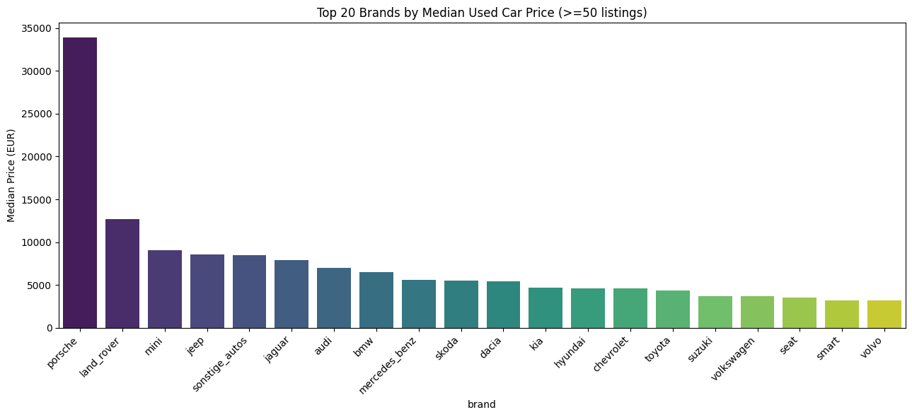
Analysis of median prices across brands highlighted strict market tiers. Premium luxury brands led the market. Porsche commanded a median price of €33,900, followed by Land Rover (€12,700). Mid-range brands like Mini and Jeep hovered around €8,500–€9,000. Business Implication: Premium stock offers vastly higher per-unit margins, but because of their high capital requirements, dealers must ensure rapid turnover compared to economy brands.

Price Vs Mileage
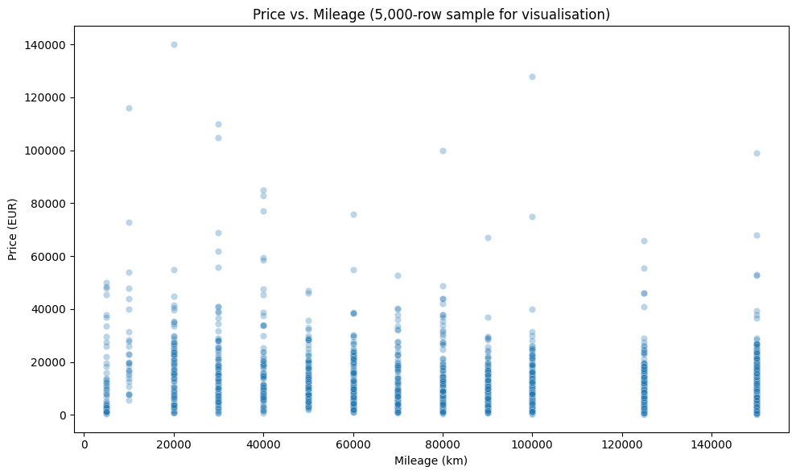
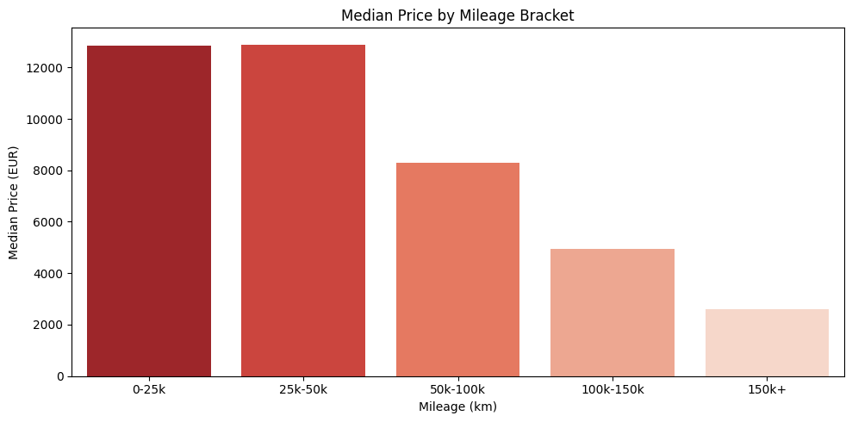
Plotting price against mileage revealed a moderate, negative Pearson correlation of -0.433. Calculating the R-squared value indicates that mileage alone dictates roughly 17% to 19% of a vehicle's price variance. Business Implication: While high mileage hurts value, a 100k-km luxury car still outprices a 30k-km economy car. Dealers cannot price vehicles based on odometer readings in isolation.

Price Vs Vehicle Age
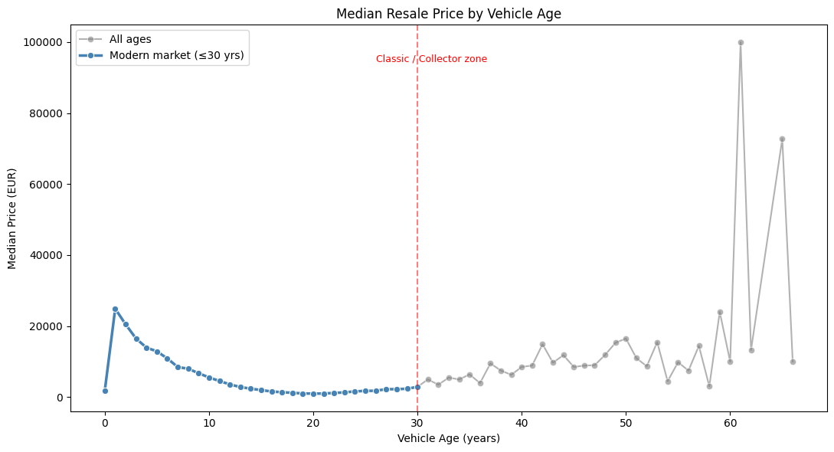
The depreciation curve based on vehicle age follows a classic trajectory: the steepest financial drop occurs in the first 5 years as the "new-car premium" evaporates. Between ages 6 and 20, the price floor flattens out. Notably, prices spike for vehicles older than 25 years due to survivor bias, transitioning into the classic/collector market.

Value Retention Analysis
Beyond raw prices, identifying which vehicles hold their value is critical for inventory risk management.
Fixed Reference Age Retention Ratio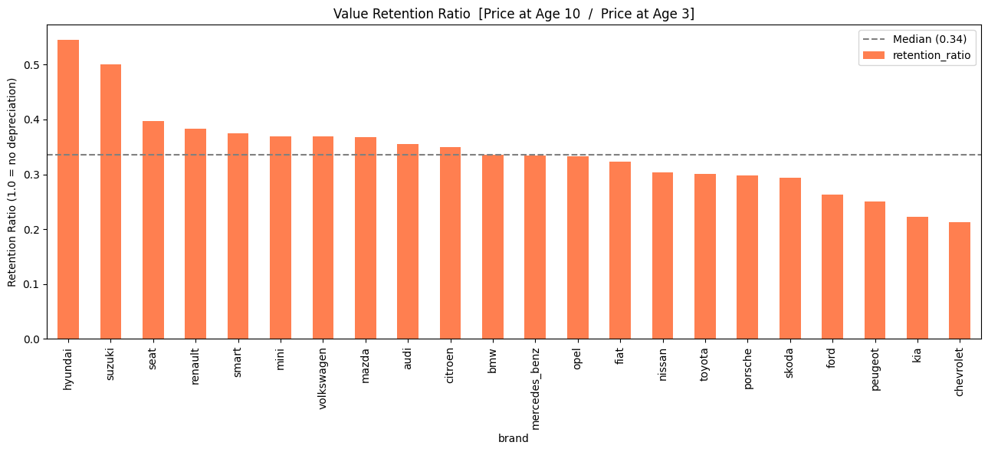
To fairly evaluate brand depreciation, a fixed reference comparison was generated, comparing a brand's median price at Age 10 against its baseline price at Age 3. Hyundai (54.6% retention), Suzuki (50.0%), and Seat (39.8%) emerged as the top leaders in mid-term value retention.
Depreciation Percentage (Age 7-9 vs 14-16)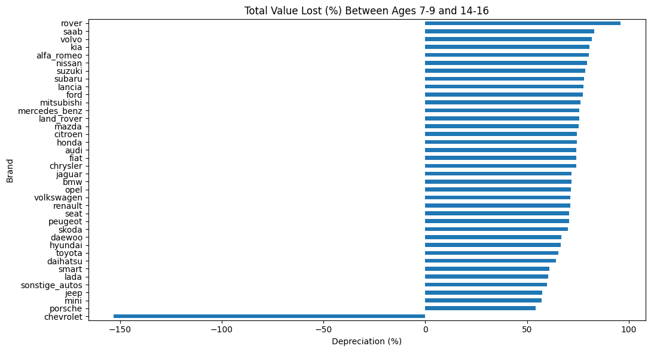
When examining the late-stage lifecycle, the percentage of value lost between ages 7–9 and 14–16 was evaluated. Brands maintaining the lowest percentage of depreciation in this window represent the safest assets for dealers holding aging, high-volume inventory.
Annual Depreciation Rate (Log-Linear Regression)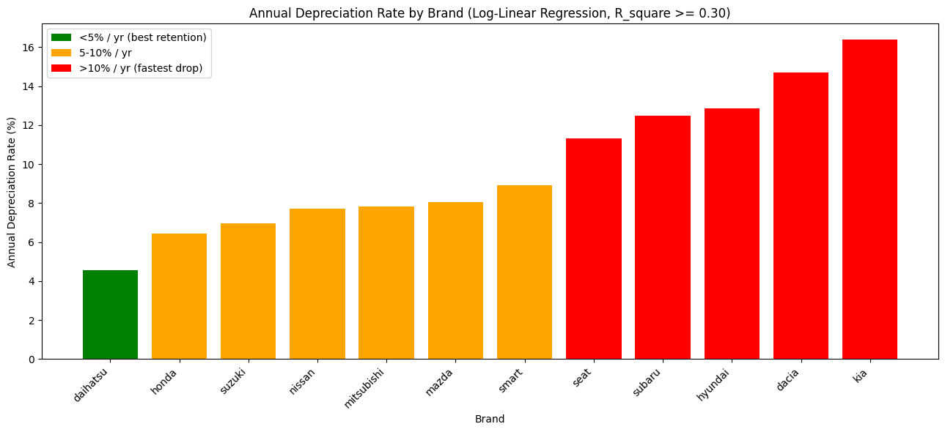
To create a definitive "Investment Ranking," a log-linear regression (log(price) ~ age) was fitted to extract continuous annual depreciation rates for brands with sufficient data and predictable trends (R² >= 0.30).
- Green Tier (<5% drop/year): Daihatsu (4.57% annual drop). Excellent for extended inventory holding.
- Yellow Tier (5-10% drop/year): Honda (6.42%), Suzuki (6.96%), Mazda (8.05%).
- Red Tier (>10% drop/year): Subaru (12.47%), Kia (16.38%). High financial risk; requires fast turnover.

Pricing Intelligence Tool
To transition from descriptive analysis to real-time decision support, a deterministic Pricing Estimator was developed. Unlike black-box machine learning models, this lookup-based tool is highly interpretable, relying on historical market medians and percentiles (Q1 to Q3).
Model Inputs & Logic The tool accepts three inputs: Brand, Mileage, and Age. It utilizes a cascading 4-level fallback mechanism:
- Level 1 (Exact Match): Finds exact historical matches for the specific brand, age, and mileage bracket.
- Level 2 (Nearest Age Match): If an exact age isn't found, it matches the brand and mileage, calculating the nearest available vehicle age.
- Level 3 (Brand Median): If mileage data is too sparse, it falls back to the overall median for that specific brand.
- Level 4 (Market Median): If the brand is entirely unknown, it falls back to overall market medians.
Sample Predictions
Brand | Mileage | Age | Estimated Q1 (€) | Estimated Median (€) | Estimated Q3 (€) | Match Level
Porsche | 85,000 | 6 | 36,125 | 38,950 | 54,625 | Level 1 (Exact Match)
Mercedes-Benz | 30,000 | 3 | 21,940 | 29,900 | 35,700 | Level 1 (Exact Match)
Volkswagen | 120,000 | 10 | 4,512 | 5,999 | 7,612 | Level 1 (Exact Match)
Practical Applications
- Dealers & Resellers: If a dealer is purchasing inventory and the seller's asking price exceeds the Q3 estimate, the vehicle is likely overpriced and will sit on the lot. Buying near Q1 ensures high margin potential.
- Marketplaces: Platforms can use this exact logic to build auto-flagging systems, warning users if a listed price falls drastically below Q1 (potential scam) or above Q3 (overpriced).

Conclusion & Summary of Findings
Transforming raw, user-generated marketplace data into structured intelligence is entirely feasible when utilizing strict data-cleaning parameters and targeted feature engineering.
Key Business Takeaways:
- Margin vs. Turnover Strategy: Porsche and Land Rover command the highest market prices (3-5x higher than volume brands). While per-unit margins are excellent, the high acquisition costs necessitate a fast-turnover strategy to mitigate holding risks.
- The Depreciation Sweet Spot: The most severe depreciation occurs in the first 5 years of a car's life. Dealers buying stock at 3–5 years old and flipping them before year 9 avoid the steepest depreciation cliff while maintaining healthy resale demand.
- Safe-Hold Inventory: Brands exhibiting an annual depreciation rate of less than 7% (e.g., Daihatsu, Honda, Suzuki) represent the most stable investments in the market. Dealers can safely hold these assets for longer periods without sacrificing significant capital.
- Holistic Pricing: Mileage accounts for ~17% of price variance, confirming that pricing must never be evaluated on mileage alone. The newly engineered Pricing Estimator resolves this by dynamically balancing brand, age, and mileage to output reliable, real-world valuation ranges.

